🗓️ Day 12

📌📌What is RTM (Requirement Traceability Matrix)?

RTM describes the mapping of Requirement's with the Test cases.

The main purpose of RTM is to see that all test cases are covered so that no functionality should miss while doing Software testing.

Trace how many Test case are execuated or covered ,in simple keep track of test cases

Requirement Traceability Matrix - Parameters include

1.Requirement ID

2.Req Description

3.Test case ID's

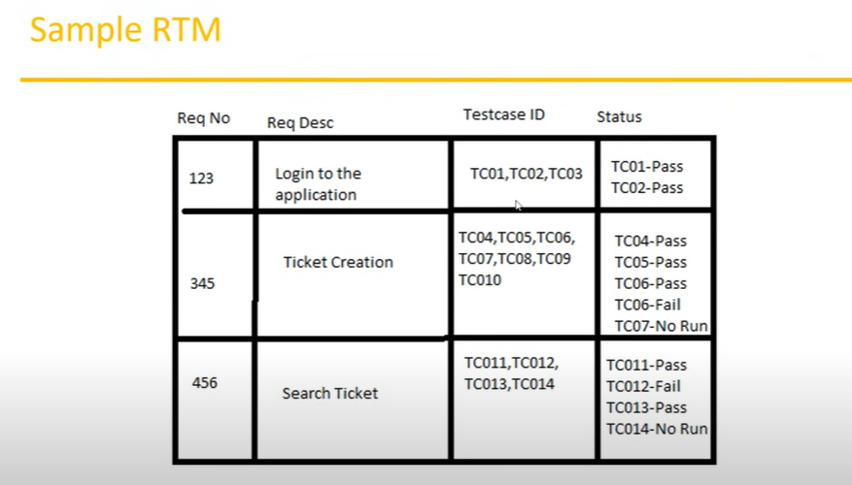

📌📌What is Test Environment ??

Test Environment is a platform specially build for test case execution on the software product.

It is created by integrating the required software and hardware along with proper network configurations.

Test environment simulates production/real time environment.

Another name of test environment is Test Bed.

📌📌Test Execution:

During this phase test team will carry out the testing based on the test plans and the test cases prepared.

Entry Criteria: Test cases, Test Data & Test Plan

Activities:

Test cases are executed based on the test planning.

Status of test cases are marked, like Passed, Failed, Blocked, Run, and others.

Documentation of test results and log defects for failed cases is done.

All the blocked and failed test cases are assigned bug ids.

Retesting once the defects are fixed.

Defects are tracked till closure.

Deliverables: Provides defect and test case execution report with completed results.

~Guidelines for Test Execution:

The Build being deployed to the QA environment is the most important part of the test execution cycle.

Test execution is done in Quality Assurance (QA) environment.

Test execution happens in multiple cycles.

Test execution phase consists Executing the test cases + test scripts(if automation).

📌📌Defects/Bugs

Any mismatched functionality found in a application is called as Defect/Bug/Issue.

During Test Execution Test engineers are reporting mismatches as defects to developers through templates or using tools.

~Defect Reporting Tools:

Clear Quest

DevTrack

Jira

Quality Center

Bug Jilla etc.

📌📌Defect Report Contents :

1.Defect_ID-Unique identification number for the defect.

2.Defect Description - Detailed description of the defect including information about the module in which defect was found.

3.Version - Version of the application in which defect was found.

4.Steps - Detailed steps along with screenshots with which the developer can reproduce the defects.

5.Date Raised - Date when the defect is raised

6.Reference- where you Provide reference to the documents like, requirements, design, architecture or may be even screenshots of the error to help understand the defect

7.Detected By -Name/ID of the tester who raised the defect

8.Status-Status of the defect, more on this later

9.Fixed by - Name/ID of the developer who fixed it

10.Date Closed -Date when the defect is closed

11.Severity- which describes the impact of the defect on the application

12.Priority -which is related to defect fixing urgency. Severity Priority could be High/Medium/Low based on the impact urgency at which the defect should be fixed respectively

